Fast**National University of Computer & Emerging Sciences, Karachi  
Fall 2019 CS-Department  
Mid-Term Exam  
21st -Oct-2019, 01:10 pm – 02:30 pm**

|  |  |  |
| --- | --- | --- |
| **Course Code: CL-203** | **Course Name: Database Systems Lab** | |
| **Instructor Name: Ammara Yaseen** | | |
| **Student Roll No:** | | **Section: B** |

**Instructions:**

* Return the question paper.
* In case of any ambiguity, you may make assumption. But your assumption should not contradict any statement in the question paper.
* You are required to submit your exam in a single text file (Questions must be in order), name your file with your student id i-e (17k-XXXX).
* Each question carry 5 marks.

**Time:** 70 minutes. **Max Marks:** 50

**Q1-**

1. Find the oldest player who belongs to team Pakistan.

Select player_name from player,team where team.team_id=player.team_id and team_name='Pakistan' and age=(select max(age) from player,team where team.team_id=player.team_id and team_name='Pakistan');

1. Display the Player’s name with all the letters in lowercase and the length of their name, for all players whose name's 2nd letter contains 'A', sort the retrieved data by player's age in descending order.

Select lower(player_name),length(player_name) from player where lower(player_name) like '_a%' order by age desc;

**Q2-**

1. Find the number of players who are playing at Lord's.

Select count (*) from player p,match m,venue v where (p.player_num=m.player_num and m.venue_name=v.venue_name and v.venue_name='Lords');

1. Find the total number of players in each team.

Select team_name,count(*) from player,team where team.team_id=player.team_id group by team_name;

**Q3-** Display the total number of players who are part of the Indian Squad and are playing in Dubai.

Select count(*) from player p,team t,match m,venue v where (t.team_id=p.team_id and p.player_num=m.player_num and m.venue_name=v.venue_name and v.venue_name='Dubai' and team_name='India');

**Q4-**

1. Select the name of the player who doesn't belong to any team.

Select player.PLAYER_NAME from player,team where team.team_id(+)=player.team_id and team_name is null;

1. Fetch the bottom-ranked team.

Select team_name from team where team_rank='Last';

**Q5-** Find all the names of the players who are playing at 10:30, irrespective of the Venue.

Select player_name from player p,match m,venue v where p.player_num=m.player_num and m.venue_name=v.venue_name and time='10:30';

**Q6-** Display name of the umpire, the venue in which he's umpiring and the total number of players playing at that particular venue.

Select u.umpire_name ,v.venue_name, count(p.PLAYER_NUM) from player p,venue v,umpire u where u.UMPIRE_ID=v.UMPIRE_ID AND u.team_id=p.team_id group by u.umpire_name, v.venue_name;

**Q7-** Display the name(s) of the team(s) in which more than 2 players are playing and at least 1 umpire is officiating.

Select TEAM_name FROM TEAM T, Player P,Umpire U where T.team_id = P.Team_id and t.team_id = u.team_id GROUP BY Team_name having count(p.player_num)>2 AND count(U.umpire_id)>=1;

**Q8-** A hotel has a pricing policy as follows:

1. 2 people: $85
2. 3 people: $90
3. 4 people: $95
4. Additional people: $6 per person

If the customer is staying on company business, there is a 20% discount. If the customer is over 60 years of age, there is a 15% discount. A customer does not receive both discounts. Given the above data, print the cost of the room.

set serveroutput on;

declare

count1 integer:=0;

type1 varchar2(10);

age integer:=0;

cost integer:=0;

begin

count1 := &count1;

if count1 = 2 then

cost := 85;

elsif count1 = 3 then

cost := 90;

elsif count1 = 4 then

cost := 95;

else cost := 95 + (count1 - 4)*6;

end if;

type1 := '&type1';

age := &age;

if type1 = 'company' then

cost := cost * (80/100);

elsif age = 60 then

cost := cost * (85/100);

end if;

dbms_output.put_line('COST: ' || cost);

end;

/

**Q9**- Write DDL for the following:

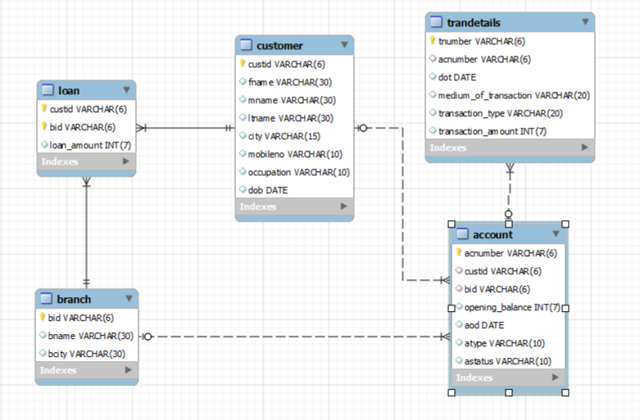

CREATE TABLE BRANCHH(

BID VARCHAR(6)PRIMARY KEY ,

BNAME VARCHAR(30),

BCITY VARCHAR(30)

);

CREATE TABLE CUSTOMER(

CUSTID VARCHAR(6) PRIMARY KEY,

FNAME VARCHAR(30),

MNAME VARCHAR(30),

LNAME VARCHAR(30),

CITY VARCHAR(15),

MOBILENO VARCHAR(10),

OCCUPATION VARCHAR(10),

DOB DATE

);

CREATE TABLE LOAN(

CUSTID VARCHAR(6),

B_ID VARCHAR(6),

LOAN_AMOUNT NUMBER(7),

FOREIGN KEY(CUSTID) REFERENCES CUSTOMER(CUSTID),

FOREIGN KEY(B_ID) REFERENCES BRANCHH(BID)

);

CREATE TABLE ACCOUNT(

ACNUMBER VARCHAR(6)PRIMARY KEY,

CUSTID VARCHAR(6),

BID VARCHAR(6),

OPENING_BALANCE NUMBER(7),

AOD DATE,

ATYPE VARCHAR(10),

ASTATUS VARCHAR(10),

FOREIGN KEY(CUSTID) REFERENCES CUSTOMER(CUSTID),

FOREIGN KEY(BID) REFERENCES BRANCHH(BID)

);

CREATE TABLE BRANCHDETAIL(

TNUMBER VARCHAR(6),

ACNUMBER VARCHAR(6),

DOT DATE,

MEDIUM_OF_TRNSACTION VARCHAR(20),

TRANSACTION_TYPE VARCHAR(20),

TRANSACTION_AMOUNT NUMBER(7),

FOREIGN KEY(ACNUMBER) REFERENCES ACCOUNT(ACNUMBER)

);

Generate Relational Model with the help of your written schema.

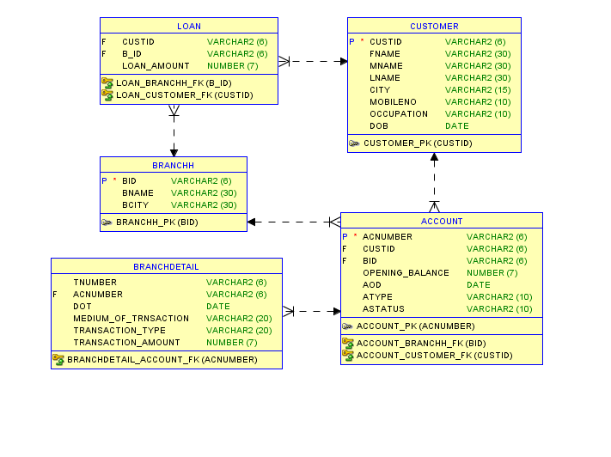

**Q10-**

1. Insert 1 record in each table of given schema (Players).Take user input while inserting in table team.

Insert into Team (team_id,team_name,team_rank) values(&team_id,’&team_name’,’&team_rank’);

Insert into Player (player_num,player_name,age,team_id) values(122250,'sohaib',19,10);

Insert into Umpire (umpire_id, umpire_name, team_id) values (10, 'Muhammad ', 50);

Insert into Venue ( venue_name, time, umpire_id) values ( 'Karachi' , '10:30' , 1 );

Insert into Match (player_num, venue_name) values (122250, 'Karachi');

1. Write query(s) to remove data of team India.

Delete from team where team_name=’India’;

Table team is parent table for the umpire table so record from parent table can’t be deleted.

If we want to delete records we should delay the constraints checking.

***BEST OF LUCK!***